**Senate Rules and Elections Committee**

**April 20, 2014**

**Jones (Chair), Grossman, Pienkowski, Wood**

**1. Contents of University Diploma**

The SREC interpreted the current wording of SR 5.4.5.A concerning the academic credentials to be displayed on an official UK diploma incompletely reflects current policy. Sean Cooper of the Registrar’s Office described to the SREC that the current UK diploma lists the following items before the conferral date:

1) Student Name

2) Degree

3) Major(s)

4) Department Honor(s)

5) Latin (University) Honors

6) University Honors Program

There is an official CIP number corresponding to each particular disciplinary field.

<http://nces.ed.gov/ipeds/cipcode/browse.aspx?y=55>

When a new degree is approved by the Council for Postsecondary Education, the appropriate CIP number for the disciplinary area of that new degree is identified and approved by CPE. For example, disciplinary field titled “Toxicology” has a CIP number of 26.1004.

The SREC interpreted that item (3) above means the local institutional description of the disciplinary field (= ‘Major Name’) of the degree that was approved within the institution and transmitted to the Council of Postsecondary Education when the proposal for approval of the degree itself was submitted to CPE. For example, the official CIP title for the disciplinary field with the CIP number 26. 0911 is “Oncology and Cancer Biology.” However, an institution could have a degree with CIP of 26.0911 that has “Cancer Biology” or “Molecular Carcinogenesis” as the institutionally-approved ‘Major Name’) - those are close enough to the intent of “Oncology and Cancer Biology.” The institution can later by internal processes update the ‘Major Name’ and include that information in its annual report to CPE of such changes.

The SREC felt that (3) above does not mean the narrower areas of emphasis lower than the CIP disciplinary field, that the KY Council of Postsecondary Education calls “specializations” (doctoral degree) or “concentrations” (master’s degree) .

The SREC will continue to obtain information to fully clarify current policy about the contents of diplomas.

**2. Diploma for Doctor of Public Health**

It was drawn to the attention of the SREC by Associate Dean James Holsinger that the current diploma for the Doctor of Public Health displays

“Student name”

“Doctor of Public Health”

“Doctor of Public Health”

Dr. Holsinger asks that the University Senate approve that the diploma be changed to show the correct display of the Major Name. The CIP established by the KY Council of Postsecondary Education when it approved this doctoral degree was 51.2201. The CIP title of the disciplinary field for this CIP number is “Public Health, General.” The SREC will continue to investigate the proper mechanism by which the University Senate approve that the diploma for the Doctor of Public Health be changed to display the academic credentials as follows:

“Student name”

“Doctor of Public Health”

“Public Health”

3. Diploma for In Memoriam Honorary Degree

The SREC recommends that the University Senate Council consider and approve an appropriate content for the *In Memoriam* Honorary Degree. The SREC offers the following as a starting point for discussion and action by the Senate Council.

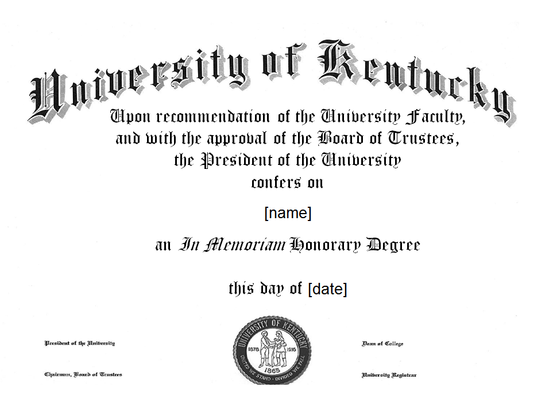

**3. Free Electives**

The SREC interpreted that the meaning of SR 5.4.3 is that each undergraduate degree program must contain a provision for at least 1 credit hour of “free elective.” Under the current Senate Rules, the role of the Undergraduate Council concerning the free elective component of undergraduate program proposals is little more than confirming that at least 1 credit hour of free elective is present and that the course or courses meet course standards set elsewhere in the Senate Rules.

**4. Does Dead Week Extend to the Weekend?**

The SREC interpreted SR 5.2.4.6 to mean that “dead week” is a seven day period that starts at 12:00 a.m. Monday and goes through 11:59 p.m. Sunday.

Grossman then left the meeting

**5. Faculty Trustee Election**

The SREC decided that if the election requires a second round of voting (because no candidate received more than 50% of the vote in the first round), then the plan is for the second (final) round to start at noon Friday May 3 and end at noon Friday May 10.